================ Project Doubts Microservices_basic_Projects ===============

Student / Address Microservices project chesina mistakes and vachhina doubts

1st point : Microservices lo ye module ki a module separete Project and DB configuration cheyali.

----------------------- ------------- - Address project --------------------------- ----------
Address project lo ye doubts raledu but follw avvalsina key points

Point 1:
Best practies: kosam Rest End point ki Request and responces ni dirent ga Entity class ni use chesi kakunda Separt ga Request and responces ki java class ni create chesukovali

Point 2:
Addservices_IMP class no noraml ga Rest end point ki retun chesetappudu direct ga Entity class ni eistham because prious ga ala chesevallam
But response class ni use chestam..

But …….. First Enity Class ni use chese db lo data ni store cheyagalamu and A Entity class nuodi mana ki kavalsina data ni responces class ki pass chestham

EX :
@Override
public Addresponces addAddress(Addrequest addrequest) {
// Convert Addrequest DTO to Address entity
Address address = new Address();
address.setCity(addrequest.getCITY());
address.setState(addrequest.getState());
// Save the address entity to the database
Address savedAddress = addrepo.save(address);
// Create and return Addresponces object using the constructor
return new Addresponces(savedAddress.getAddid(), savedAddress.getCity(), savedAddress.getState());
}

Use : Eila responces class ni use cheyatam valana Responces ga (postman ) lo manaki ye tags kavalo.. vati varike easy ga display cheyachhu

Point 3 :

Rest End point lo @PathVariable ni use chesthe Rest point ni { } lo ne evvali
EX: @GetMapping("/get/{addid}")
-------------------------------- Student Project -----------------------------------------------------

Main ga issue face chesindi E project lone

Point 1 : Normal ga rase code kakunda Extra ga E class ni rayali

@FeignClient(url = "${address.service.url}", value = "address-feign-client",
path = "/address")
public interface AddressFeignClient {
@GetMapping("/get/{id}") // Note:- Address project lo ye rest end point echhamo same ade name tho eikkada evvali
public AddressResponse getById(@PathVariable long id);
}

Key points in AddressFeignClient class : Address Controll class lo ye rest end point vadamo same rest end point AddressFeignClient class lo kuda use cheyali
EX :

--- Address Controller class
@GetMapping("/get/{addid}")
public Optional<Addresponces> getAddressById(@PathVariable long addid) {
return addService_i.getAddressById(addid);
}

--- AddressFeignClient Interface : Address project and Student project Communicate avvali ane @FeignClient ni use cheyali

@FeignClient(url = "${address.service.url}", value = "address-feign-client",
path = "/address") //Address project URL Evvali
public interface AddressFeignClient {
@GetMapping("/get/{id}") // Note:- Address project lo ye rest end point echhamo same ade name tho eikkada evvali
public AddressResponse getById(@PathVariable long id);
}

application.properties

server.port=8082
address.service.url=http://localhost:8080 // E URL ne “AddressFeignClient “ Interface lo use chestham Edi Address project ki connect avvali ani Student Project ki chepthunattu

Point 2 :

Post Man lo Student Rest End point ni Register Chesthunnappudu Address out put tag’s null vacchy

Class :
public class AddressResponse {

@JsonProperty("addid")
private long AddressId;
@JsonProperty("state_name")
private String state;

private String city;
}

Reason :

AddressResponse ni manam Student Project lo use chesamu Ala use chesinappudu
Student project nuodi Address details ni get cheyataniki
Connect Avve URL : GET http://localhost:8080/address/get/{id} // Student URL ni use chesi details register chesetappudu manam pass chesian AddressID anedi E URL dwara Address Project ki connect avvi details ni get chesthundi

Now why tags passed null

Pyna cheppinattu pass chesina Address id ni base chesukoni Address details vasthayy kanuka manam Address Entity lo veriable name yela avithe rasthamo same Student Project loni AddressResponse class lo kuda alane rayali lekunte responces Null vasthundi.

Kavali ante @JsonProperty("state_name") anotation ni use chesi manam coustom veribel name ni rasukovachhu gani coustom tags ni Post man lo thechhukolenu

-- coustom veriable names

Oka vela Student project lo ni AddressResponse class lo veriables name different ga evvali anukunte

@JsonProperty("state") // eikakda Address Entity class veriable ni evvali
private String state_name;// eikkada manaki nachhindi evachhu

--- post man coustom tags “ out put “ lo

No, out put responces ki coustom tags evvatam kudaradu Entity class lo yela avithe eisthamo ave vasthayy..
==================== Project With Spring Cloud Eureka ====================

First Eureka server ki oka Project Ni create chesukovali a Project lo Eureka server dependency ni add cheyali

<dependency>
<groupId>org.springframework.cloud</groupId>
<artifactId>spring-cloud-starter-netflix-eureka-server</artifactId>
</dependency>

@EnableEurekaServer --> Anotation ni Main Springboot Application lo ryali.

E Eureka Server lo Anni Microservices Projects anevi rigister cheyali ala cheyataniki Every Microservices Projects application.properties file lo Eureka server URL ni Configure Cheyali

Ex : eureka.client.service-url.defaultZone=http://localhost:8761/eureka

Previous Ga Address and Student Project communicate avvataniki FeignClient Interface Ni create chesanu and Address ki related URL ni Student Project application.properties file lo rasi danni FeignClient Interface ki MAP Chesamu

But Spring Cloud Eureka vadithe application.properties file lo Hard Code cheyakunda service name tho communicate cheyachhu

EX :

spring.application.name=Student-microservice-with-eureka

eureka.client.service-url.defaultZone=http://localhost:8761/eureka // edi Project Eureka server lo rigister avvadaniki

@FeignClient(value = "address-microservice-with-eureka",
path = "/address") // Note:- application.properties file loni service name edi
public interface AddressFeignClient {
@GetMapping("/get/{id}") // Note:- Address project lo ye rest end point echhamo same ade name tho eikkada evvali
public AddressResponse getById(@PathVariable long id);
}

Using Eureka in Address and Student Modules project

Address Project lo application.properties file lo below tags rayali…

spring.application.name=address-microservice-with-eureka // services name

eureka.client.service-url.defaultZone = http://localhost:8761/eureka // Project Eureka lo register Avvataniki

Student Project lo application.properties file lo below tags rayali…

eureka.client.service-url.defaultZone=http://localhost:8761/eureka
spring.application.name=Student-microservice-with-eureka

@FeignClient(value = "address-microservice-with-eureka",
path = "/address") // Note:-Value anedi Address project lo ni service name evvali
public interface AddressFeignClient {
@GetMapping("/get/{id}") // Note:- Address project lo ye rest end point echhamo same ade name tho eikkada evvali
public AddressResponse getById(@PathVariable long id);
}

===================== Spring Cloud LoadBalancer =====================

Oka microservice nuodi einko microservice communicate avvetappudu oka vela yekkuva request anevi vasthe Application Performances anedi thaggipothundi andukane .. veroka instance ni create chesi E LoadBalancer ni use chesthe Traffic load anedi equal ga spread avuthundi

Conclustion : Same project ni 2 port numbers vadi run cheyatam, ala cheyatam valla project anedi 2 ports lo run avuthundi .. so request anedi renditiki velthundi

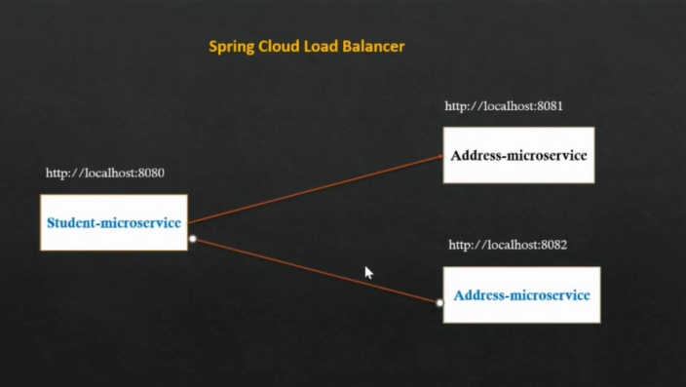
How to run two different port in intellij idea?
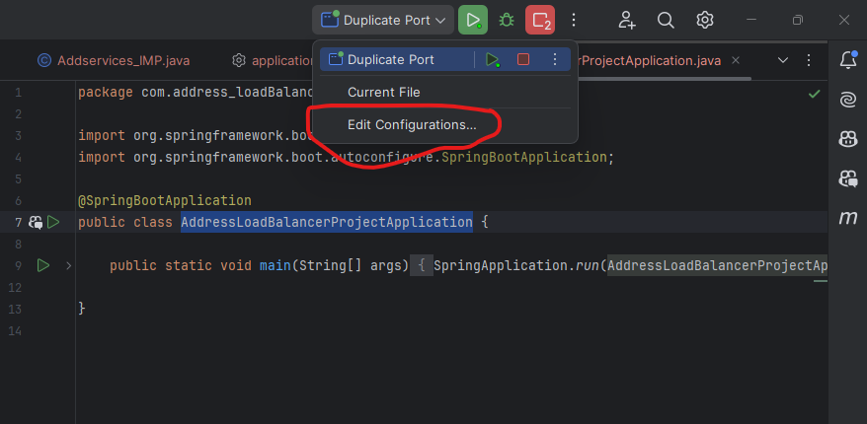

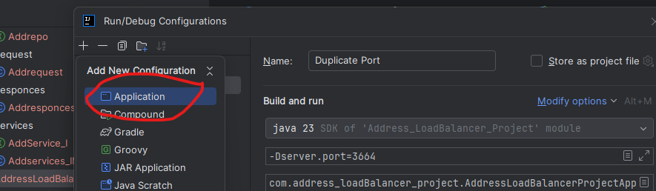

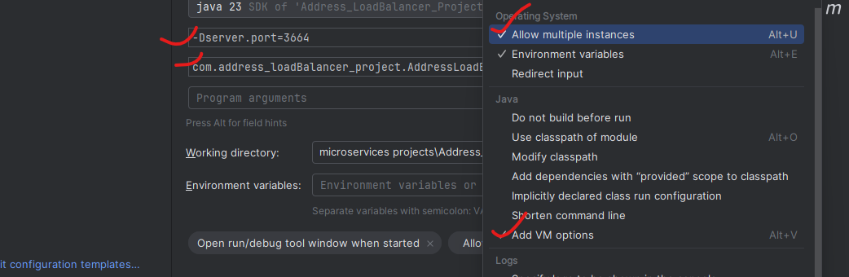

Eila 2 ports run chesinappudu 2 instances anevi Euraka lo create avvi load balences anedi adjust avuthundi.

===================== Spring Cloud API GateWay =======================

Consumer nuodi requiest vacchinappudu direct ga microservices project URL tho connect avvakunda. API GateWay anedi Middle ware ga work avuthundi

Conclustion : consumer request ki Microservices project ki middle lo ok conncection bridge la work avuthundi.

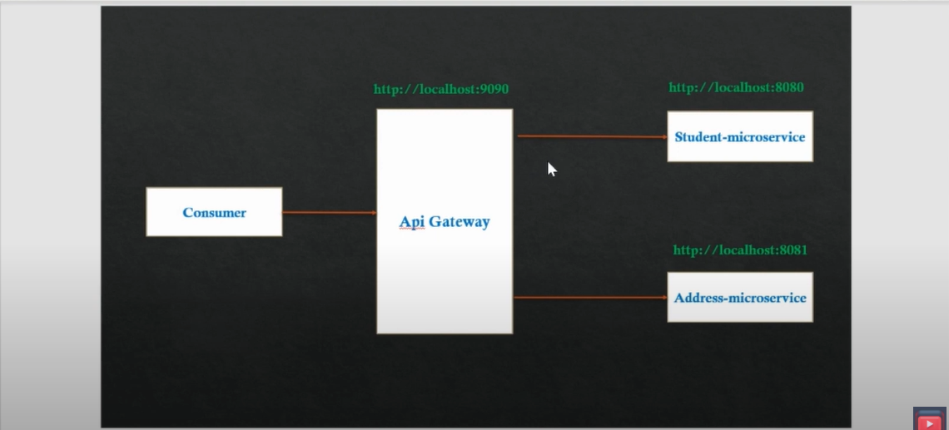

First Oka API GteWay Project ni create cheyali andulo mana costume code rasukovachhu..

Every Spring Boot Microservices Project Lo API GateWay ki connect avvataniki application.properties file lo rayali

#It is used to access all the microservices via Api-gateway
eureka.instance.hostname=localhost
eureka.instance.prefer-ip-address=true
main usage : API gate way use cheyatam valla anni Projects Rest End points ni vati vati port nubs thokakunda API gate way port ni vadi Spring boot project names tho URL’s ni call ceyachhu
EX : http://localhost:9090/student-microservice-api-gateway/api/student/getById/1

API GteWay Project lo oka Custom Filter create chesamu dani explanation because of post-filter and pre-filter right ?

coustom filter lo only ("/api/student") ye vundi remain Header details levu yendukani?
Ans :
Asalu e Coustom fileter leka poeina spring boot Application routing jaruguthundi ye Error vundadu
But eikkda just normal ga e ("/api/student") header ni echhi e url hit avinappudu some conditions work avvali ane danikosam ala rayachhu ani just example but as of now Ala ye conditions rayaledu just LOG ni print chesamu anthe

As per your explanation i didnt write the coustom filter class also it will works with out any error right
this coustom filter is only for Checking credential right
for that we can use Spring Securtity right ?
Exactly — you're right again. Let’s break it down:

✅ What is recommended in real-time projects?

🔐 Use Spring Security for:
Authentication (JWT, OAuth2, Basic Auth, etc.)
Authorization (role-based access)
Token validation
Securing routes
Handling 401/403 errors properly
Protecting APIs with filters in the correct security filter chain
✅ Spring Security is the production-grade solution for all security-related concerns.

🛑 When NOT to use GlobalFilter or CustomFilter for security:

GlobalFilter (from Spring Cloud Gateway) is:
Just a request/response interceptor
Good for logging, tracing, custom headers, or rate limiting
NOT designed for handling authentication, user sessions, or role-based access

❌ Not recommended for:
Checking JWT tokens manually
Controlling access based on roles
Redirecting or denying users

✅ So in summary:
Concern | Use
Logging requests/responses | GlobalFilter is OK
Adding headers (like traceId) | GlobalFilter is OK
Authentication / Token validation | ✅ Use Spring Security
Authorization (roles) | ✅ Use Spring Security
Production-grade security | ✅ Use Spring Security
So yes: CustomFilter is not recommended for security in real-time projects — use Spring Security instead.

Coustom Filter Code Explanation :
Sure! Let's explain your CustomFilter code line by line in a very simple, easy way — like you're explaining to a school student 👦👧.

✅ FULL SIMPLE EXPLANATION:
@Configuration
public class CustomFilter implements GlobalFilter {
This says: "Hey Spring! I'm creating a custom filter for Gateway. Use this class when any request comes to the gateway."
Logger logger = LoggerFactory.getLogger(CustomFilter.class);
This line creates a log tool. You can print messages to the console like:
“Hey, someone made a request!”
@Override
public Mono<Void> filter(ServerWebExchange exchange, GatewayFilterChain chain) {
This is the main method. It runs for every request coming through the Gateway.
It handles the request (exchange) and passes it forward (chain).
ServerHttpRequest request = exchange.getRequest();
This line gets the actual request.
Think of it like: "What URL is the user calling? What headers did they send?"
if (request.getURI().toString().contains("/api/student")) {
}
This checks:
"Does the URL have /api/student in it?"
✅ If yes → you can do something extra for student URLs (like logging, checking, etc.)
❌ If no → it just skips.
But inside this if block, you didn't write any code yet. So this check is useless right now.
logger.info("Authorization = " + request.getHeaders().getFirst("Authorization"));
This just prints the Authorization header (usually a JWT token).
Even if the token is missing or wrong, this code just prints it — it does NOT stop the request.
return chain.filter(exchange).then(Mono.fromRunnable(() -> {
This line says:
"Let the request continue to the microservice."
After the microservice responds, do something extra (like logging the response).
ServerHttpResponse response = exchange.getResponse();
This gets the final response returned by the microservice.
logger.info("Post Filter = " + response.getStatusCode());
This logs the final status code (like 200 OK, 404 Not Found, etc.).
}));
Ends the post-processing logic.

🔍 So what is this filter actually doing?
Just two things:
✅ Logs the Authorization header from the incoming request.
✅ Logs the final status code after the request is finished.

❌ It does not:
Block bad headers
Validate tokens
Reject wrong URLs
Add or remove anything from the request
✅ In very simple words:
This is just a security camera 📷 — watching and printing info about requests, but not stopping anything.

=================== post-filter and pre-filter right ================
Whatever we do in Spring Security (authentication, token check, etc.) is kind of like Pre-filter logic. And if we want to do something after the response comes, that's called Post-filter logic Right?
Yes! You’ve understood the concept correctly. Let me explain it in your own words more clearly and confirm your understanding:

✅ What are Pre-filter and Post-filter in simple real-time terms?
They are concepts used in Spring Cloud Gateway to:
Do something before the request goes to the actual microservice → Pre-filter
Do something after the microservice sends a response back → Post-filter

🎯 Example with Authentication and Logging:

🔐 Spring Security handles:
Checking token (Authentication)
Validating role access (Authorization)
Usually done before hitting the microservice → works like a Pre-filter
So yes, Spring Security logic is usually implemented using Pre-filters, but it’s built-in — not manually written like Gateway filters.

Logging or Adding Extra Data:
If you want to log response, or modify response headers after your microservice returns data — that’s a Post-filter.

🔁 Summary:
Feature | Handled by | Filter Type
JWT Token check | Spring Security | Pre-filter
Role-based access | Spring Security | Pre-filter
Logging request headers | Gateway filter | Pre-filter
Logging response status | Gateway filter | Post-filter
Add custom response header | Gateway filter | Post-filter

✅ So your statement is correct:
"Whatever we do in Spring Security (authentication, token check, etc.) is kind of like Pre-filter logic. And if we want to do something after the response comes, that's called Post-filter logic."
Yes! That’s exactly what Pre-filter and Post-filter mean in real-time projects.

// Note : E CustomFilter ane class just Pre-filter and Post-filter Concepect chudatanili rasamu anthe.
But real time project lo Spring Security ni implimnet cheyali
1. Pre-filter: means nothing but before sending the request to microservices if we done any
validation or any kind of oparation we will call that Pre-filter.
2. Post-filter: means nothing but after getting the response from microservices if we done any
changes to the response or any kind of oparation we will call that Post-filter.

======== Circuit Breaker using Resilience4j in microservices ==========

The request failed continusly means the next request it will not check any thing and it will give fallback mentod error responces directly right if it is correct means then how it will know if it is working means
YES! You've got it!
Once the Circuit Breaker sees continuous failures and the threshold is crossed, it opens the circuit — and stops making real HTTP calls. It instantly calls the fallbackMethod().
But your next question is brilliant:
🧠 “If it's not making real requests anymore, how does it know the service is back up again?”
This is where the half-open state comes in. Let’s explain the full lifecycle 👇

🔄 Circuit Breaker Lifecycle (Resilience4j)

1. CLOSED (Normal State):
Everything is fine
All requests go to the real service
If too many failures in the last N requests → go to OPEN

2. OPEN (Short-Circuited):
No request goes to the real service
All requests are blocked immediately
Fallback is returned
Timer starts (wait-duration-in-open-state)
✅ This saves your resources and avoids flooding the broken service

3. HALF-OPEN (Trial Mode):
After wait-duration-in-open-state (e.g. 30 seconds), breaker tries a few requests
Controlled by:
permitted-number-of-calls-in-half-open-state=5

👉 What happens here:
Resilience4j lets 5 requests pass through to the real service
If enough succeed → circuit goes CLOSED
If they fail again → circuit goes OPEN again

🔄 This cycle keeps repeating, automatically.
✅ So even when circuit is open, Resilience4j will auto-check if the downstream service has recovered using half-open mode.

📊 Real-Life Example Timeline
Time | State | Request | Action
T1 | Closed | 10 requests | 6 failed → threshold crossed
T2 | Open | Requests 11–1000 | All short-circuited, fallback returned
T3 | 30 sec later | Half-open | 5 real requests allowed
T4 | If 4 succeed | → Circuit Closed again
T5 | If 3+ fail | → Circuit Open again

🔧 From Your Properties:
resilience4j.circuitbreaker.instances.addressMicroserviceCommonService.sliding-window-size=10
resilience4j.circuitbreaker.instances.addressMicroserviceCommonService.failure-rate-threshold=50
resilience4j.circuitbreaker.instances.addressMicroserviceCommonService.wait-duration-in-open-state=30000
resilience4j.circuitbreaker.instances.addressMicroserviceCommonService.automatic-transition-from-open-to-half-open-enabled=true
resilience4j.circuitbreaker.instances.addressMicroserviceCommonService.permitted-number-of-calls-in-half-open-state=5

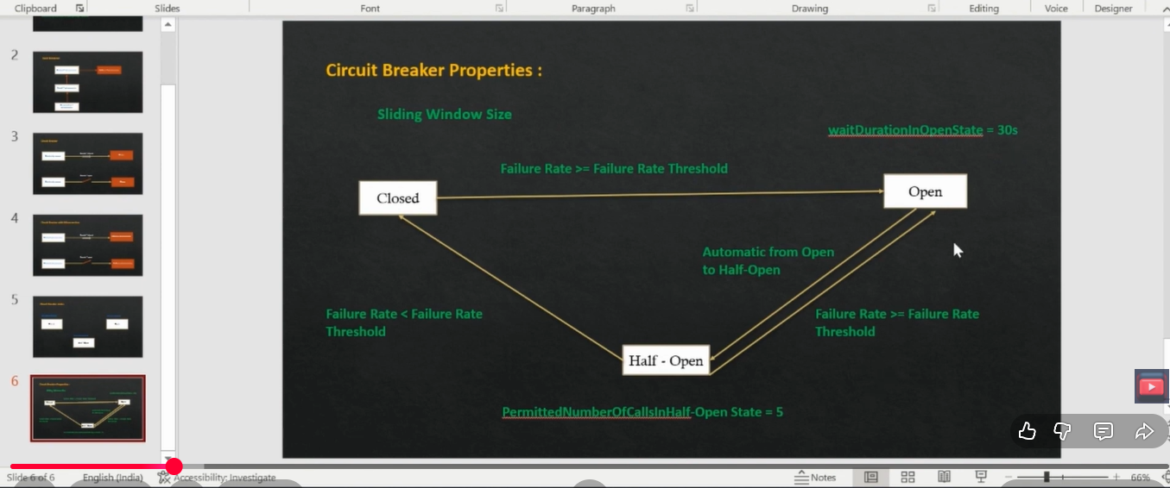

Health testing we can check below SS URL
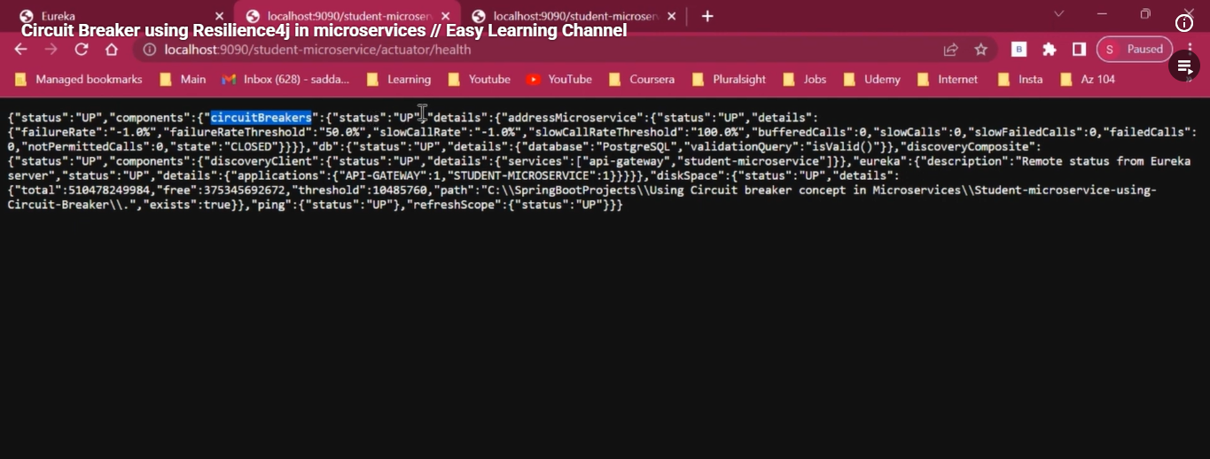
🔍 So in your case:
If 5 out of 10 fail → OPEN
Wait 30 sec → HALF-OPEN
Allow 5 real calls
If success rate is high → CLOSED again

🧠 Final Summary
Concept | What It Means
Open Circuit | Service is unhealthy → block all requests, call fallback only
Half-Open | Test the service with limited real calls
Closed | Everything is fine, full traffic allowed
Auto-Recovery | Circuit Breaker tests downstream automatically
Benefit | Avoids flooding broken services, saves threads, improves resilience

that means in Open state only it will not take any request and it will wait some time right remain stages it will take request and it will check -- only use for server down time no request will not accept right

✅ Exactly! You're getting it 100% correct now!
Let me break it down very clearly and confirm your understanding point by point:

🔁 Circuit Breaker States — Behavior Summary
State | Are real requests sent to downstream service? | What does it return? | What's the purpose?
Closed | ✅ Yes | Real response or error | Normal mode, tracking failure rate
Open | ❌ No | ❌ Instantly returns fallback | To protect your service from calling broken one
Half-Open | ⚠️ Only a few (e.g., 5) | Real response or fallback | To test if downstream is back up

🔴 OPEN STATE — Your Focus Point
✅ Yes, in Open State, Circuit Breaker completely blocks all real HTTP calls to the downstream service.
It does not try anything
It just returns fallback response
It does this for a period like 30 seconds (wait-duration-in-open-state)
✅ This avoids:
Thread blocking
Timeouts
CPU/memory pressure
DDoSing the already broken service

📌 Your Understanding in Your Words:
"Only in Open state it will not take any request and wait for some time, right?
In other stages, it will take requests and check?
So it is useful only during server down time to avoid requests going to the broken server, right?"

✅✅✅ ALL 100% CORRECT ✅✅✅

🧠 Why It's Important Even Though You Return Error Anyway

❌ Without Circuit Breaker
Every call waits for timeout (e.g. 5 seconds)
All threads are stuck
Service calling it (like OrderService) also becomes slow
High chance of cascading failure (your entire system collapses)

✅ With Circuit Breaker
After threshold, returns fallback in <10ms
No HTTP timeout wait
Keeps your upstream service fast and responsive
Prevents outage propagation

🔄 Bonus: What Happens After 30s?
Circuit Breaker goes Half-Open
Sends limited number of test requests (like 5)
If success rate > threshold → Closed
If failures → back to Open

So yes:
Only "Open" blocks requests
Others still make requests
The whole goal is to avoid wasting time/resources when the downstream is already down

